tlog2chart_P3 — User Manual

Version: v1.3.12
Scope: Visualize tlog RF power, caps, and each voltage

Contents
tlog2chart_P3 — User Manual 1
1. Overview 2
2. Main Tabs 3
2.1 Graph Tab 3
2.2 Parameters Tab 5
2.3 Tlog Array Tab 6
2.4 Smith Chart Tab 6
2.5 Analysis Input Tab (Task G) ✅ 6
3. Analysis Workflow 8
4. Step 3 — Custom Time‑Range Analysis (Task G) 10
4.1 Step 3 Figure 10
4.2 Step 3 Metrics Table 10
5. Word Report Export 11
6. Units & Timebase Summary (Important) 13
7. Common Mistakes & Tips 14
8. Version Notes (v1.3.5) 15

1. Overview
tlog2chart_P3 is a GUI tool for analyzing RF generator/matching network tlog data.
It allows users to:

Visualize RF power, caps, and Vpp signals
Inspect raw tlog data
Analyze RF behavior in a user‑defined time window
Generate a Word report that reflects exactly what the user selected on the graph

Recommended workflow:
Load tlog → study Graph → assign custom time range and power scale → Analysis Input → Run Analysis → Export to Word Report

2. Main Tabs
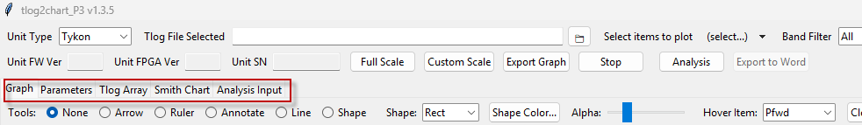

2.1 Graph Tab
The Graph tab is the primary analysis workspace.
Key features
Multi‑panel Y-axis plot (Power(W) / Caps(%) / Bias) (You could add or remove the items on ‘Select items to plot’)
X‑axis uses time in seconds t(s)
Interactive tools:
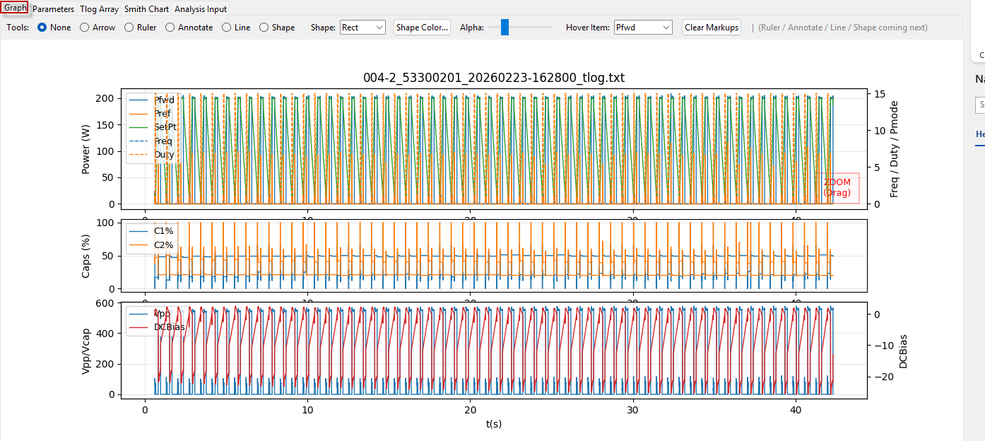
Zoom & pan
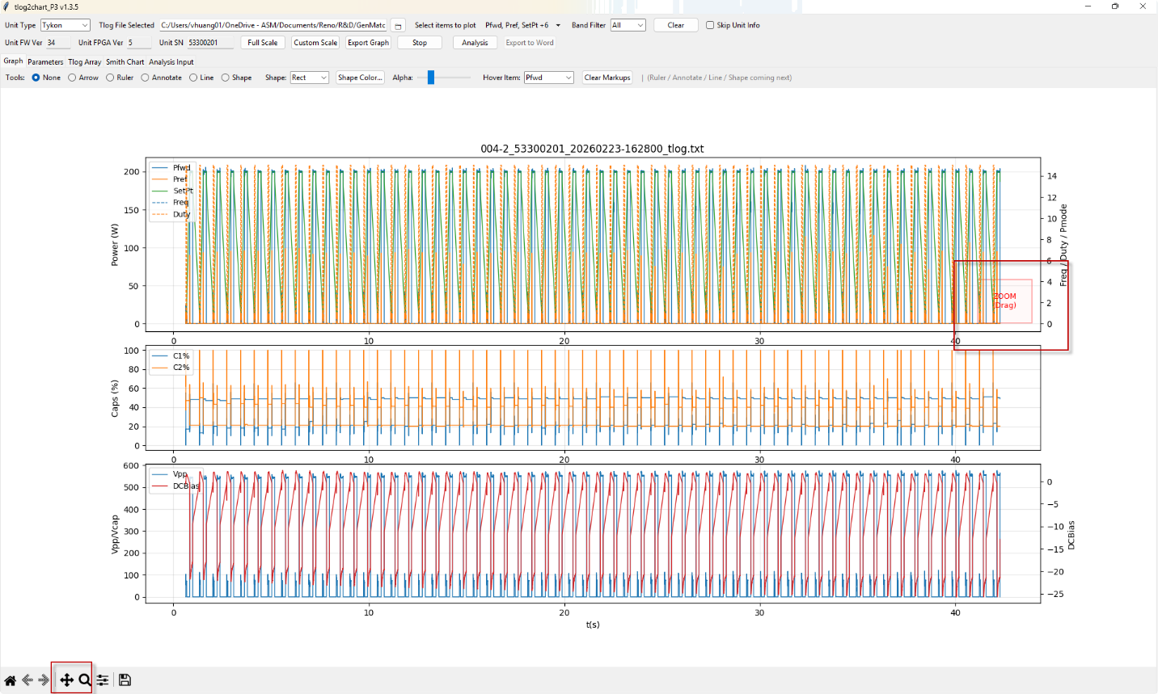
Please deselect pan and magnifying glass when you zoom in or zoom out.
Ruler (time & value measurement)
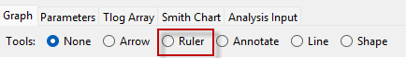
Hover tooltip showing:
row()
t(s)
signal value
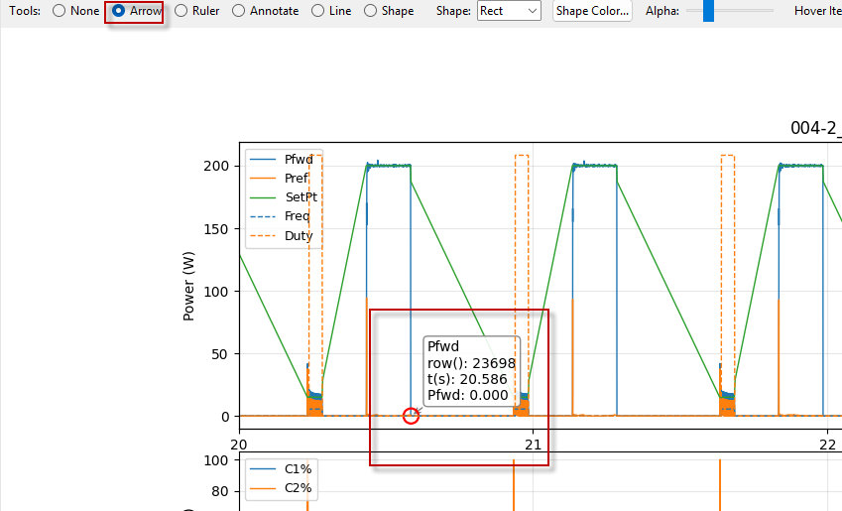

Important

The graph timebase is seconds, not milliseconds.
All analysis time windows are interpreted against this axis.

2.2 Parameters Tab
Displays parsed tlog parameters in a structured table.
Section / Parameter / Value / Description
Read‑only reference information
Useful for understanding generator configuration

2.3 Tlog Array Tab
Raw tlog data browser.
Features

Paginated view (2500 rows per page)
Horizontal & vertical scrollbars
Go‑to‑row function
Right‑click row highlighting in yellow for multiple line selections

Use cases

Inspect exact numeric values
Cross‑check timestamps (t(s), time(ms), etc.)
Debug abnormal behavior seen in Graph

2.4 Smith Chart Tab
Displays load impedance trajectory.

Smith chart with Z₀ = 50 Ω
Based on EVC Zload data
Visual separation between chart and info panel
You could increase the slide bar to remove low power info

2.5 Analysis Input Tab
This is the new tab introduced for analysis purpose.
Purpose
Define a custom time window for Step 3 analysis.
Inputs
Start (s)
End (s)

Both values are in seconds, consistent with the Graph x‑axis.
Buttons
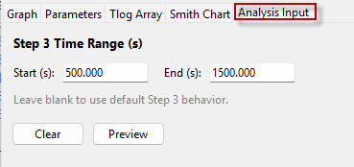
Preview
Shows the parsed time range and validates it.
Clear
Resets the fields.

Validation behavior

If fields are blank → default analysis is used
If non‑numeric → warning
If Start > End → warning
If outside graph time span → warning and analysis is blocked

✅ This prevents accidental inputs that are out of range.

3. Analysis Workflow
Step 1 — Load Tlog
Open the application
Load a valid tlog file
Graph and Tlog Array populate automatically

Step 2 — Inspect Graph
Use zoom and ruler tools
Identify the region of interest on t(s) axis
Example: 20.0 – 23.0 s

Step 3 — Define Analysis Window (Optional)
Go to Analysis Input
Enter:
Start (s): 20
End (s): 23

Click Preview to confirm
If left blank, the tool falls back to default behavior.

Step 4 — Run Analysis
Click Analysis
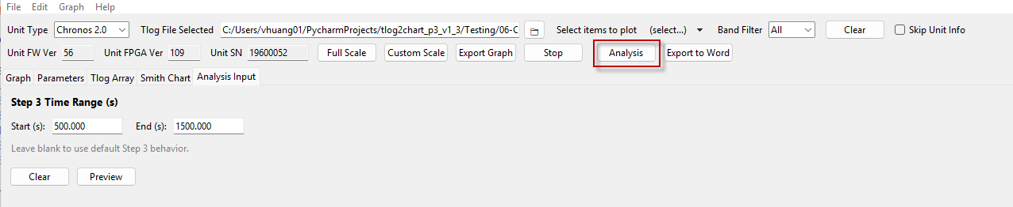
The tool generates analysis artifacts:

Step 1: report overview now summarizes full-scale duration, mode classification, max forward power, second-highest forward power, and RF ON/OFF cycle count.
Step 2: report view now shows the last 2 seconds of the tlog instead of a full-span/100 zoom rule.
Step 3: report figure caption updated to `Power plot for the user-selected custom time range.
Step 4: Forward power alarm report is with unit-aware setpoint handling and alarm-focused output.
Step 5: Reflect power alarm report
Step 6: Pulse alarm report

4. Analysis Step 3 — Custom Time‑Range Analysis

4.1 Step 3 Figure

Uses time slicing, not cycle index slicing
Plots exactly the data within the user‑defined time window
Timebase matches the Graph (seconds)

Title
Step 3 — Customize Time Range RF Cycle Analysis (Start – End s)

This guarantees:

What you see on Graph = what you get in the report

4.2 Step 3 Metrics Table

Analyzes all RF cycles overlapping the selected time window
This provides meaningful, context‑specific metrics.

5. Word Report Export
How to export

After Analysis completes, click Export Word Report
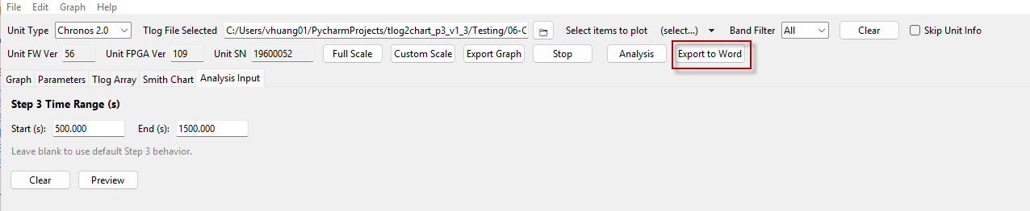
Report contents
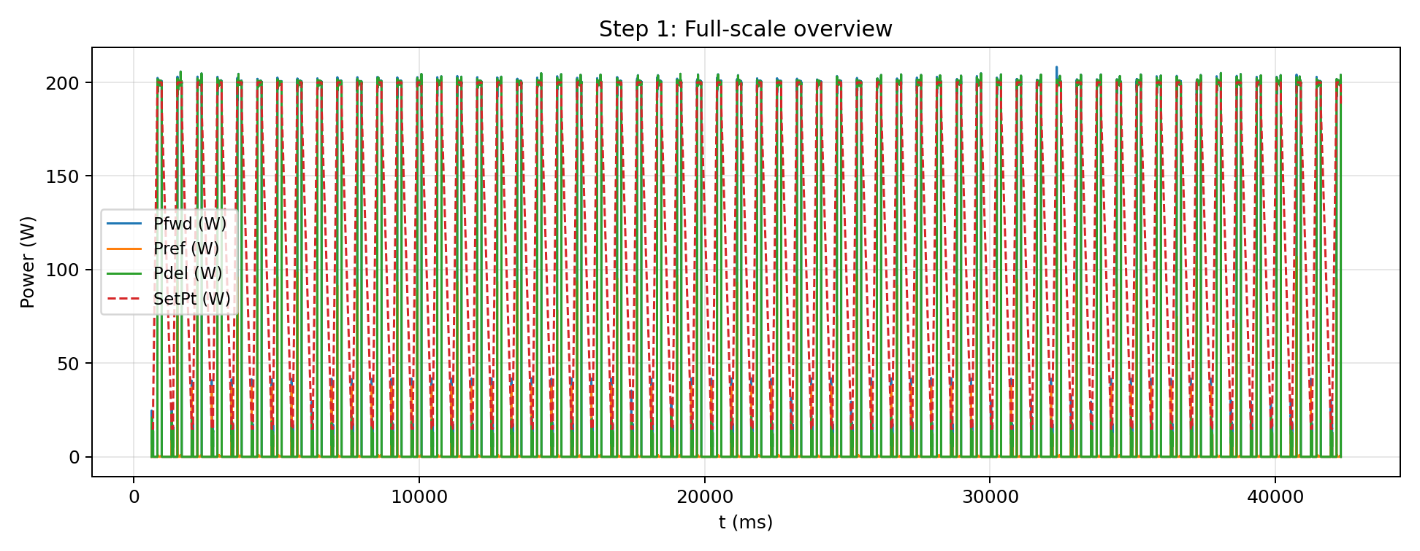
Figure 1: Full‑scale overview

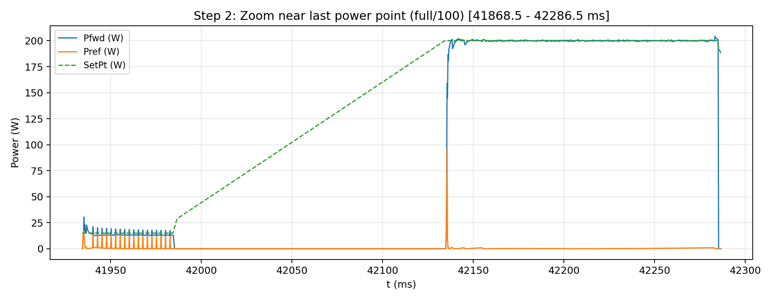
Figure 2: Zoom in last 2 seconds
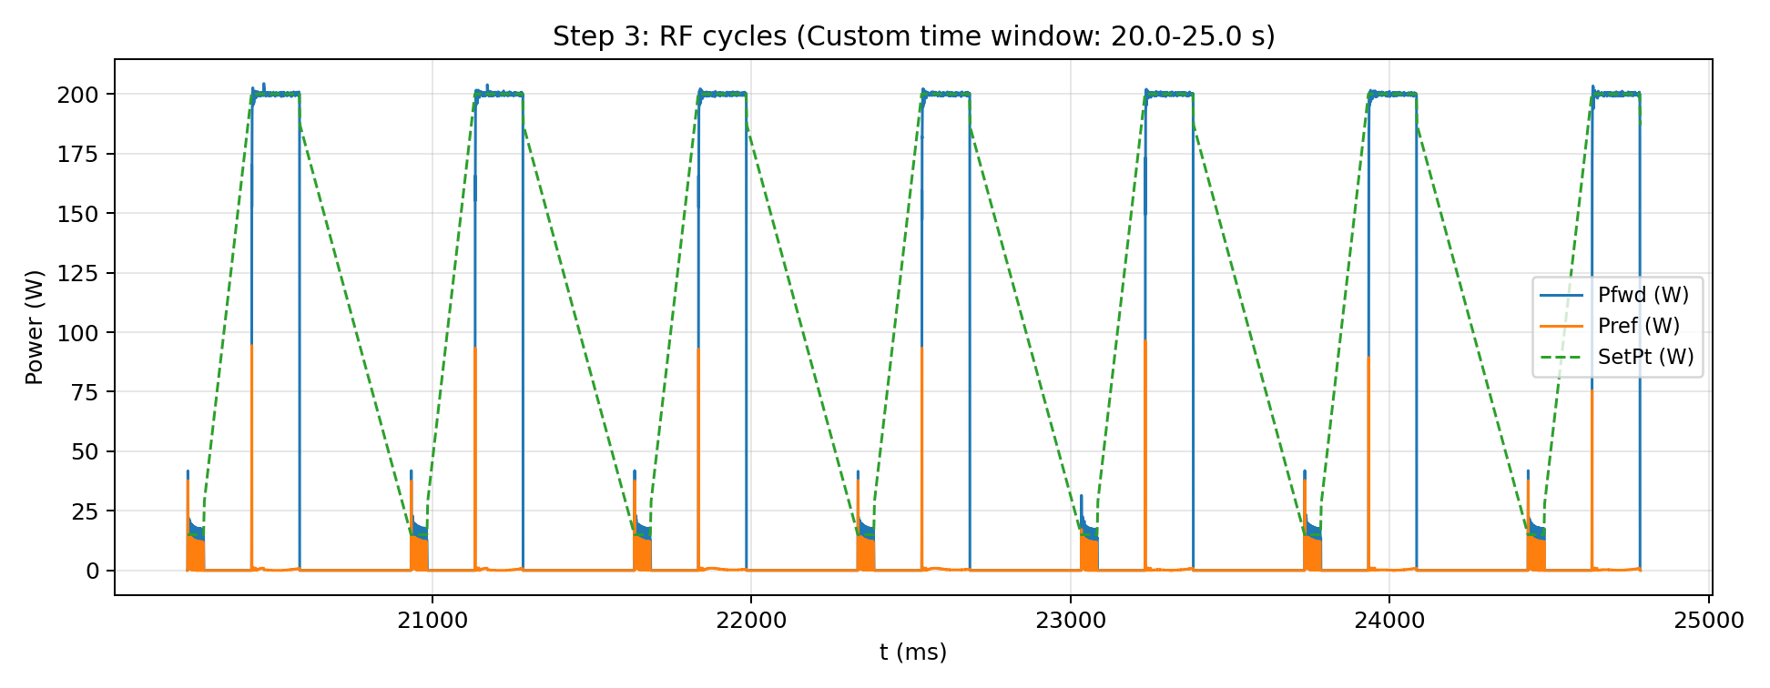
Figure 3: Custom time‑range analysis
Step 3 table reflects only cycles in the selected window

Guaranteed behavior
Figure 3 is embedded if data exists
No silent failures
Titles and captions match the analysis mode

6. Units & Timebase Summary (Important)

Location | Unit | Source
Graph x-axis | seconds t(s) | df["t(s)"]
Analysis Input | seconds | User input
Step 3 slicing | seconds | Time window
Report Figure 3 | seconds | Consistent

Rule: Always read the Graph first, then enter the same values for analysis input in seconds.

7. Common Mistakes & Tips
❌ Entering milliseconds (e.g. 20000–23000)

Will be rejected as out of range
Correct input would be 20–23

✅ Best practice

Use ruler tool on Graph to read exact start/end in seconds
Copy those numbers into Analysis Input

8. Version Notes (v1.3.12)
## [1.3.12] - 2026-03-30
### Changed
- Step 4 alarm report is finalized for all product families with unit-aware setpoint handling and alarm-focused output.
- Step 6 section in the Word report is now explicitly presented as a dedicated pulse-mode alarm step.
- Bumped application version to 1.3.12.

### Added
- Step 6 now flags `PulseFreqNotDetected` and `PulseDutyNotDetected` when pulse mode is present but frequency/duty values are missing or invalid.
- Step 6 now explicitly reports CW-only logs as: `No pulse mode detected in this tlog (CW-only).`

### Verified
- Step 4 and Step 5 behavior remains stable after Step 6 updates.

## [1.3.11] – 2026-03-29
### Changed
- Step 1 report overview now summarizes full-scale duration, mode classification, max forward power, second-highest forward power, and RF ON/OFF cycle count.
- Step 2 report view now shows the last 2 seconds of the tlog instead of a full-span/100 zoom rule.
- Step 3 report figure caption updated to `Power plot for the user-selected custom time range.`
- Bumped application version to 1.3.11.

### Fixed
- Corrected Step 1 duration calculation to use the continuous tlog time base.
- Corrected Step 1 second-highest Pfwd logic to ignore RF ramp-up data immediately after RF ON and require a value at least 20% below the maximum.
- Restored Step 3 custom time-range figure generation in the Word report.
- Corrected Step 3 plot x-axis to preserve the user-selected absolute time range instead of rebasing the sliced plot near 0 seconds.
- Corrected Step 3 metrics to use only RF cycles overlapping the selected custom time window.
- Fixed GUI-to-analysis handoff so the Step 3 custom time range is actually passed into `p3_run_analysis()`.

## [1.3.10] – 2026-03-29
### Added
- Splash screen with progress bar on application startup: displays company logo, app name, and real-time module loading status (NumPy, Pandas, Matplotlib, PIL, docx) while heavy imports run in a background thread; dramatically improves perceived startup time for the frozen EXE.

### Changed
- Bumped application version to 1.3.10.

## [1.3.9] – 2026-03-24
### Changed
- Removed all debug print statements (`[TIMEDBG]`, `[DBG]`, `[CLEAN]`) from `tlog_reader.py` and `gui_app.py` for clean production output.
- Bumped application version to 1.3.9.

### Fixed
- Multi-tlog (double-download) file support confirmed working; multiple data-header segments are correctly detected, parsed, and concatenated.

## [1.3.8] - 2026-03-21
### Added
- Tetris submenu under Help to launch bundled Tetris game as a separate process; log output is shown in a transient window for diagnostics.
- Instruction dialog with clearer, professional workflow steps (larger font for readability).

### Changed
- Bumped application version to 1.3.8

### Fixed
- Robust Tetris launcher: uses project root as cwd and displays child process stdout/stderr in a log window; falls back to threaded launch if needed.

## [1.3.6] – 2026-03-09
### Fixed
- Task I: Tykon1213 logs with leading timestamp prefixes now parse correctly (timestamp stripped before header detection).
- Task I: Chronos 2.0 header detection supports `sec ms` format and normalizes to canonical `sec,_ms.`.
- Task I: Chronos 2.0 parsing fixed for `C1c,f` and `C2c,f` tokens like `0, 0` (prevents column shift).
- Task I: Chronos 2.0 Step 3 metrics table restored using RF status column `RF`.
- Task I: Quantum (Q2013) RF ON/OFF naming differences handled (Step 3 metrics works).

### Improved
- Custom Scale dialog: “Carry X → Analysis Input” button added to copy X range into Step 3 time window.
- Analysis: removed unnecessary “Phase 3 analysis started…please wait…” popup.
- Graph toolbar: “Select items to plot” pull-down made more noticeable (hand cursor + hover emphasis).

## [1.3.5] – 2026-03-08
### Added
- New “Analysis Input” tab
- Step 3 custom time-range analysis (user enters start/end time; report focuses on that window)

### Changed
- Step 3 report title and narrative updated to reflect custom time-range analysis
- Step 3 metrics table now analyzes cycles/segments within the user-selected time window (not limited to first 6)

### Fixed
- Prevent out-of-range Step 3 inputs via GUI validation (warn if outside data range)
- Align Step 3 analysis timebase with Graph timebase to avoid mismatch between Graph and report

## [1.3.2] – 2026-03-xx
### Added
- Annotate tool (click → input text → place label; multiple; Clear Markups supported)
### Changed
- Tool routing: zoom zone always wins across all tool modes
### Fixed
- Prevent Ruler from falling back to legacy two-click handler (legacy kept but unused)
---
## [1.3.1] – 2026-03-05
### Changed
- Ruler tool upgraded to JMP-style drag workflow (press→drag preview→release finalize)
- Support multiple ruler lines (temporary markups)
### Fixed
- Hover interactions stabilized across Graph and Smith chart

